Multiple Features

Linear regression with multiple variables is also known as "multivariate linear regression".

We now introduce notation for equations where we can have any number of input variables.

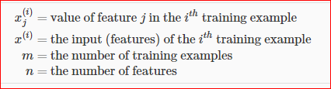

The multivariable form of the hypothesis function accommodating these multiple features is as follows:



In order to develop intuition about this function, we can think about *θ*0 as the basic price of a house, *θ*1 as the price per square meter, *θ*2 as the price per floor, etc. *x*1 will be the number of square meters in the house, *x*2 the number of floors, etc.

Using the definition of matrix multiplication, our multivariable hypothesis function can be concisely represented as:

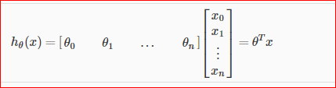

This is a vectorization of our hypothesis function for one training example; see the lessons on vectorization to learn more.

Remark: Note that for convenience reasons in this course we assume *x*(*i*)0=1 for (*i*∈1,…,*m*). This allows us to do matrix operations with theta and x. Hence making the two vectors '*θ*' and *x*(*i*) match each other element-wise (that is, have the same number of elements: n+1).]

SSrao: My point is to Transpose of x multiply with theta. Because that way we can add more set of theta values also.